Geometry Study Guide

A point is pictured by a dot.

A line segment is a straight path between two points.

A line is a straight path that goes on forever in both directions.

A ray is a straight path that goes on forever in one direction.

Parallel lines are lines that never cross.

Intersecting lines are lines that cross over at a point.

Perpendicular lines are lines that intersect to form right angles.

An angle is formed by two rays connecting at a vertex. There are three types of angles: acute, obtuse, and right.

- An acute angle is less than 90⁰.

- A right angle is exactly 90⁰

- An obtuse angle is greater than 90⁰.

A polygon is a flat shape consisting of at least 3 straight sides. There are many types of polygons.

Triangles
- Triangles are polygons with three sides and three angles.

Quadrilaterals
- Quadrilaterals are polygons with four sides and four angles.
  - Square: All sides are the same length. There are four right angles.

  - Rectangle: Opposite sides are parallel and the same length; there are four right angles

  - Parallelogram: two pairs of opposite parallel sides

  - Rhombus: two pairs of parallel sides; all sides are the same length

  - Trapezoid: only one pair of parallel sides

Other Polygons

Pentagon Hexagon Heptagon Octagon
(5 sides) (6 sides) (7 sides) (8 sides)

Nonagon Decagon
(9 sides) (10 sides)

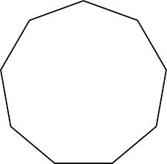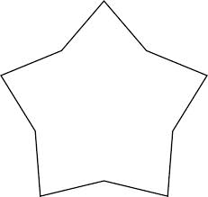

Congruent figures are the same shape and size.

Similar figures are the same shape but might be different in size.

You can move a figure with a translation, reflection, or rotation.

- Translation = slide

- Reflection = flip

- Rotation = turn

